**Project Report: GenZ Career Aspirations**

**1. Project Overview and Methodologies**

***Project Overview***

This project analyses the career aspirations of *Generation Z (Gen Z)*, focusing on their **preferences**, expectations, and concerns as they enter the workforce. A **significant challenge faced by *Gen Z*** is the gap between their **aspirations and the opportunities** or conditions provided by employers. Concurrently, **employers struggle to attract, retain, and manage *Gen Z* talent**. This project explores key factors driving these **challenges and provides actionable insights** for both *employers and Gen Z individuals.*

**Methodologies Used**

* **Data Collection**: A comprehensive analysis was conducted using a dataset of *Gen Z* respondents from India, capturing data on **gender**, **career preferences, and industry interests and other parameters.**
* **Data Cleaning & Standardization**: The dataset underwent meticulous cleaning and standardization to ensure consistency across fields such as gender and country, utilizing tools like **Microsoft Excel** for preprocessing.
* **Tools Utilized**: Excel pivot tables derived insights from the dataset. The dataset was also converted into **CSV format** and imported into a **MySQL** **database** for advanced analysis using **SQL queries**.
* **Dashboards**: Three insightful dashboards were created to visualize the data:
  + - 1. **Learning Aspirations**
      2. **Manager Aspirations**
      3. **Mission Aspirations**

**2. Key Findings and Stakeholder Analysis**

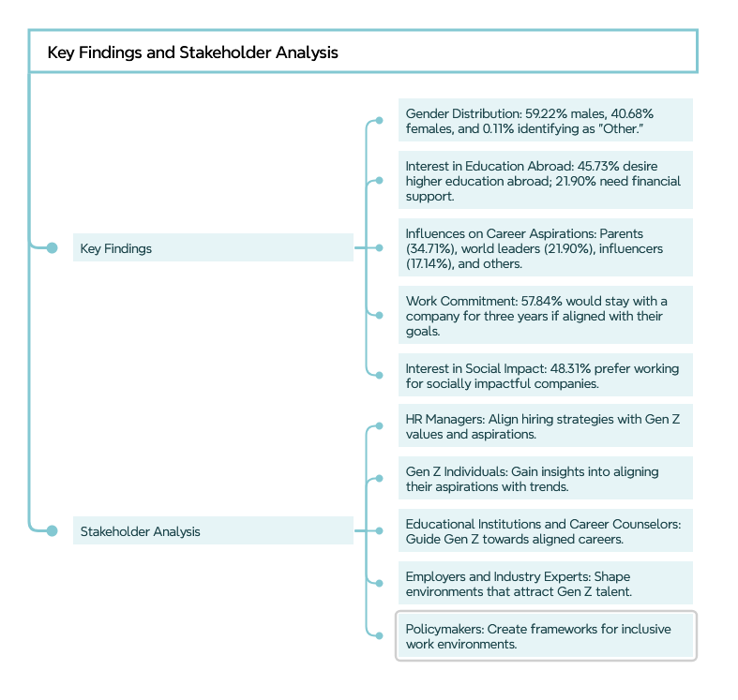

**Key Findings**

1. **Gender Distribution:** The respondent pool comprised **59.22% males, 40.68% females,** and **0.11%** identifying as "*Other*."

2. Interest in **Education Abroad: 45.73%** of respondents expressed a **desire to pursue** higher education abroad, with **21.90% requiring financial sponsorship.**

3. **Top Influences on Career Aspirations**: Influences identified included:

* + **Parents**: *34.71%*
  + **World** **Leaders**: *21.90%*
  + **Influencers**: *17.14%*
  + **Acquaintances**: *14.66%*
  + **Social** **Media**: *10.57%*
  + **Friends**: *0.63%*

4. **Work Commitment**: Approximately **57.84%** would remain with a company for three years if it aligned with their goals.

5. **Interest in Social Impact**: **48.31%** showed a preference for working at socially impactful companies.

**Stakeholder Analysis**

* **HR Managers**: Essential for aligning hiring strategies with *Gen Z*'s values and aspirations. They can utilize insights to attract and retain talent by addressing preferences for flexible working, career development, and company mission alignment.
* ***Gen Z* Individuals**: The primary beneficiaries of this analysis, providing them a comprehensive understanding of how their aspirations align with broader trends.
* **Educational Institutions and Career Counsellors**: Vital for guiding *Gen Z* toward careers aligned with their aspirations and improving employer-employee communication about career expectations.
* **Employers and Industry Experts**: Insights into preferences regarding work options, salary expectations, and mission alignment will assist in shaping environments that attract *Gen Z* talent.
* **Policymakers**: Can create supportive frameworks for an inclusive work environment for *Gen Z* by encouraging transparency in company missions and employee welfare.

**3. Project Outcomes and Challenges**

**Project Outcomes**

* **Data-Driven Insights:** The analysis provided critical insights into influences on career aspirations, work preferences, and salary expectations, which can be leveraged by employers and educational institutions.
* **Learning Aspirations:** Notable interest in pursuing higher education abroad, with many respondents *requiring sponsorship*, opens avenues for companies to support educational aspirations.
* **Manager Aspirations:** A strong preference for hybrid work setups and negative perceptions of abusive management were revealed, indicating that a positive management culture is essential for retention.
* **Mission Alignment:** A focus on companies with **clear, actionable missions** suggests that organizations with **well-communicated values** stand a better chance of retaining *Gen Z* employees.

**Challenges Faced**

* Data Cleaning: Ensuring dataset accuracy and completeness was a significant challenge, requiring extensive standardization for uniformity.
* Varied Preferences: Significant differences in *Gen Z*'s preferences across demographics, such as gender and work environment, complicated the delivery of universal recommendations.

**4. Lessons Learned and Recommendations**

**Lessons Learned**

1. **Diversity in Aspirations**: *Gen Z's* career aspirations vary widely by gender and work environment preferences, necessitating flexible employer strategies.

2. **Importance of Mission Statements**: Companies that communicate and act on their missions are more likely to retain *Gen Z* employees; *clarity in communication* is crucial for alignment.

3. **Management Matters**: A supportive work environment underpinned by *effective management* is vital; thus, *leadership development* should be prioritized.

**Recommendations**

* **Flexible Work Environments:** Employers should provide flexible work arrangements, including hybrid or remote options, to meet *Gen Z* expectations.
* **Educational Support:** Organizations should consider sponsorship or educational support for employees wishing to further their education, particularly abroad.
* **Mission Alignment:** Companies must ensure their missions are not only clearly articulated but also genuinely reflected in their practices to maintain trust.

**5. Five 'Wow' Insights**

**1. Interest in Education Abroad:** *45.73%* of respondents expressed a desire for education abroad, with 21.90% needing sponsorship, presenting an opportunity for supporting companies.

**2. Abusive Management Rejection:** An overwhelming *83.26%* of respondents indicated they would not work under abusive management, making workplace culture a critical factor in career decisions.

**3. Preference for Hybrid Work:** A notable *46.57%* favoured a hybrid work model, reinforcing the demand for flexible arrangements.

**4. Mission Misalignment Risks Turnover:** *76.22%* would leave a company if its mission was unclear or inconsistent with actions, emphasizing the importance of authentic corporate values.

**5. Work-Life Balance Needs Variability by Gender:** Reports of work-life balance interventions revealed differing needs by gender, highlighting the necessity for personalized employee wellness programs.

**6. Conclusion**

This report presents a detailed exploration of the **aspirations, preferences,** and **challenges** faced by *Gen Z* employees, accompanied by actionable recommendations for employers and educational institutions. The insights *gleaned from this analysis* lay the groundwork for fostering a more *aligned and conducive work environment* for the future workforce.

This Report

Made By: [Umesh Kumar](https://www.linkedin.com/in/u11kumar/)

Made For: [KultureHire.com](https://kulturehire.com/)